Celebal Technologies Internship - Week 5 Assignment

Apache Spark (PySpark)
Name: Saksham Agarwal
Internship: Celebal Technologies Data Engineering Internship
Week: 5
Q1: What are the key limitations of traditional MapReduce that make Spark a preferred choice for modern big data processing?

Ans- Traditional MapReduce has the following limitations:
- It stores intermediate results on disk, which makes processing slow.
- It is inefficient for iterative algorithms such as Machine Learning.
- It has higher latency for interactive queries.
- It requires multiple MapReduce jobs for complex workflows.
- Data processing is more complex because of repeated disk I/O.
Spark is preferred because it supports in-memory processing, faster iterative computations, interactive queries, and a simpler programming model.

Q2: Explain how Spark uses In-Memory Computing to speed up iterative machine learning algorithms compared to disk-based systems.
Spark can cache or persist data in memory using operations such as:
df.cache()
In traditional disk-based systems, every iteration reads data from disk and writes intermediate results back to disk. Spark stores frequently used data in RAM, allowing subsequent iterations to access it much faster.
This is especially useful for algorithms such as:
K-Means
Logistic Regression
Decision Trees
PageRank
Therefore, Spark significantly reduces disk I/O and improves the performance of iterative Machine Learning algorithms.
Q3: Write a code snippet to remove all duplicate rows from a DataFrame based on a specific set of columns: user_id and transaction_date.
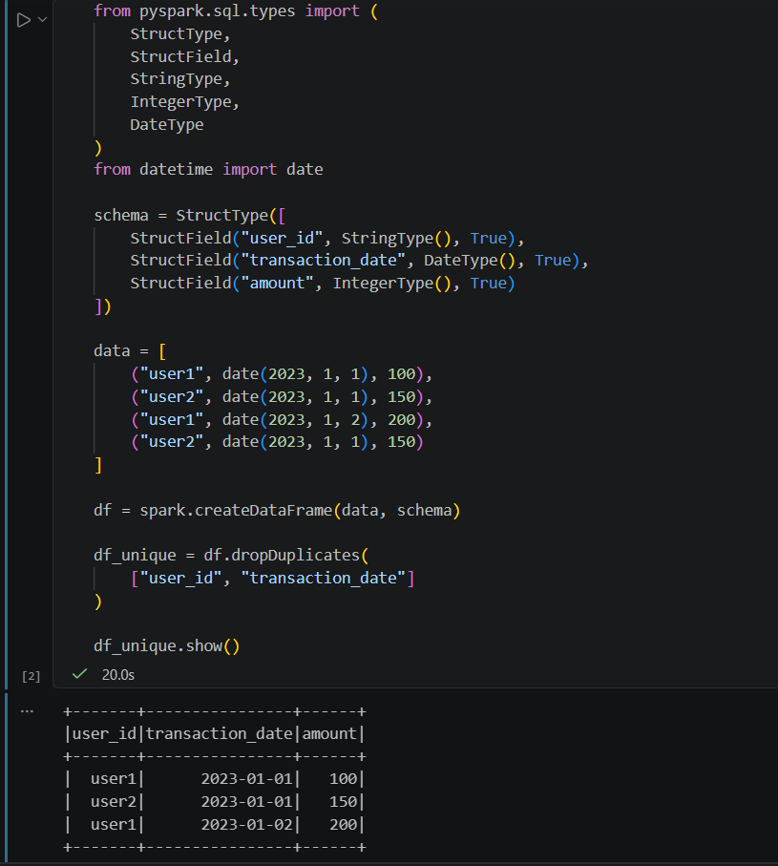

Q4: Given a DataFrame df_sales, write a query to filter for rows where the region is 'West' and then group by product_category to find the average sale_amount.
from pyspark.sql.types import (
StructType,
StructField,
StringType,
IntegerType
)

sales_schema = StructType([
StructField("region", StringType(), True),
StructField("product_category", StringType(), True),
StructField("sale_amount", IntegerType(), True)
])

sales_data = [
("West", "Electronics", 1000),
("West", "Electronics", 1500),
("West", "Furniture", 800),
("West", "Furniture", 1200),
("East", "Electronics", 2000),
("South", "Furniture", 900)
]

df_sales = spark.createDataFrame(
sales_data,
sales_schema
)

df_sales.show()

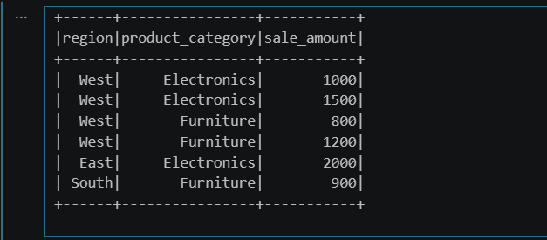

from pyspark.sql.functions import col, avg

result = (
df_sales
.filter(col("region") == "West")
.groupBy("product_category")
.agg(
avg("sale_amount").alias("average_sale_amount")
)
)

result.show()

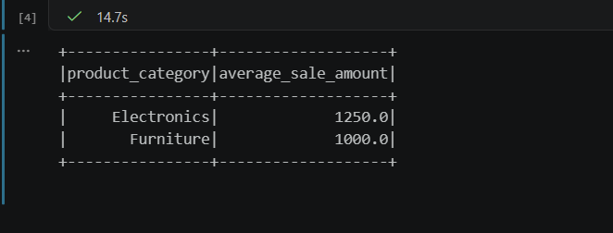

Q5: What is the difference between .na.drop() and .na.fill()? Provide a code example of filling null values in a status column with the string 'Unknown'.
.na.drop()` removes rows containing null values. `
.na.fill()` replaces null values with a specified value.
In this example, null values in the `status` column are replaced with `"Unknown"`.

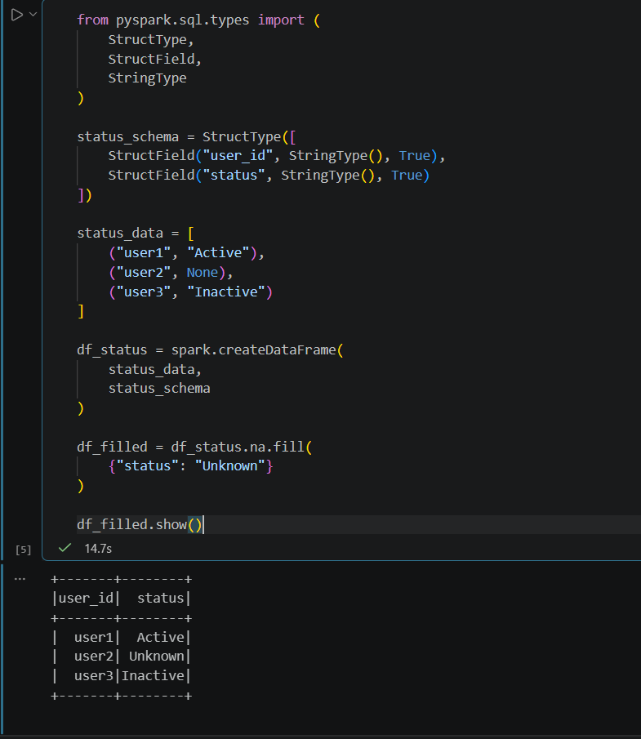
Q6: Write a query to find the total count of records for each city in a DataFrame, but only for cities where the count is greater than 100.
Group the DataFrame by city, count the records, and keep only cities where the count is greater than 100.
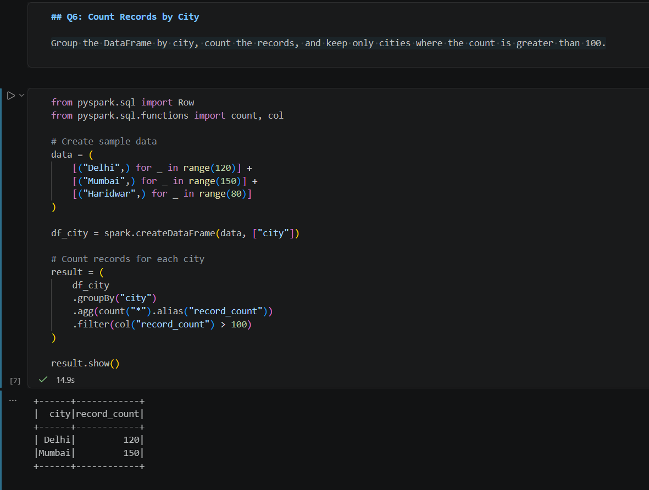

Q7: How does the immutability of Spark DataFrames affect how you perform "data cleaning" steps like dropping columns or renaming them?

Ans-Spark DataFrames are immutable, which means that they cannot be changed directly after they are created.

Data cleaning operations such as dropping columns or renaming columns create a new DataFrame. The original DataFrame remains unchanged.

For example:

df_new = df.drop("unwanted_column")

df_renamed = df.withColumnRenamed("old_name", "new_name")
Q8: Write a Spark command to filter a dataset for rows where the age is between 18 and 30 (inclusive) and the subscription is 'Premium'.
Filter rows where the age is between 18 and 30, inclusive, and the subscription is Premium.
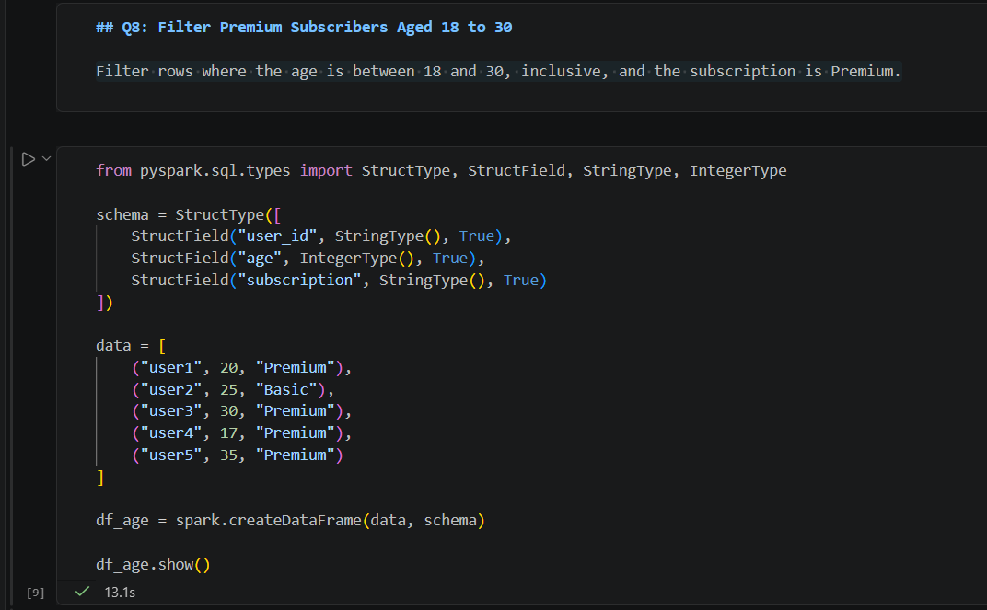

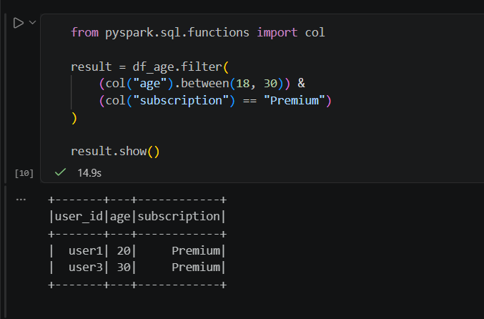

Q9: When cleaning a dataset, why is it often better to handle null values before performing mathematical aggregations like sum() or avg()?
Ans-Null values should often be handled before mathematical aggregations such as `sum()` and `avg()` because missing values can affect the accuracy and interpretation of the results.
Depending on the situation, null values can be removed or replaced with an appropriate value. For example, missing prices may be replaced with 0 when a null value represents no revenue.
Cleaning null values first makes the aggregation results more reliable and consistent.
Q10: Write the code to revise a column named raw_timestamp by casting it to a TimestampType and renaming it to event_time.
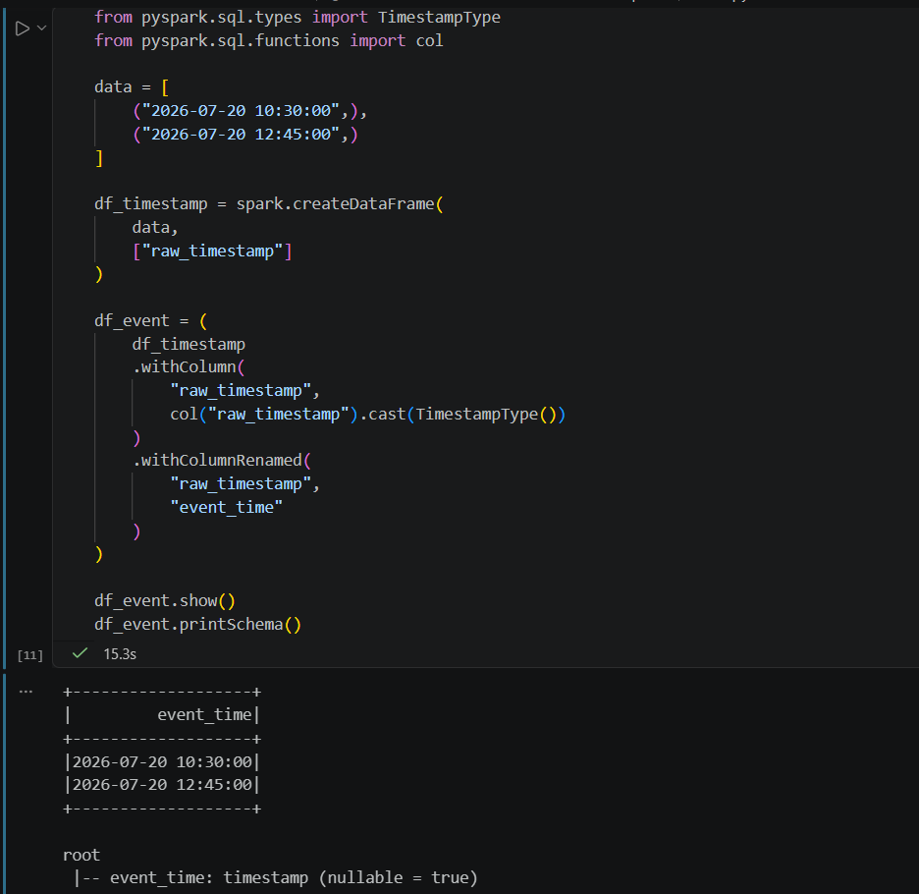
Ans-Cast the `raw_timestamp` column to `TimestampType` and rename it to `event_time`.

Q11: Explain the "Shuffle" process that occurs during a grouping operation. Why is it considered a wide transformation?
A Shuffle occurs when Spark redistributes data between partitions during operations such as `groupBy()`, `join()`, and `distinct()`.
Ans-For example, during a groupBy operation, records with the same key may be located in different partitions. Spark moves these records across the network so that all records with the same key are brought together.
It is called a wide transformation because an output partition may depend on data from multiple input partitions.
Shuffle operations can be expensive because they involve network communication, data movement, and sometimes disk I/O.
Q12: Write a code snippet that identifies and removes rows where the email column contains null values OR the username is an empty string.
Ans-Remove rows where the email is null OR the username is an empty string.
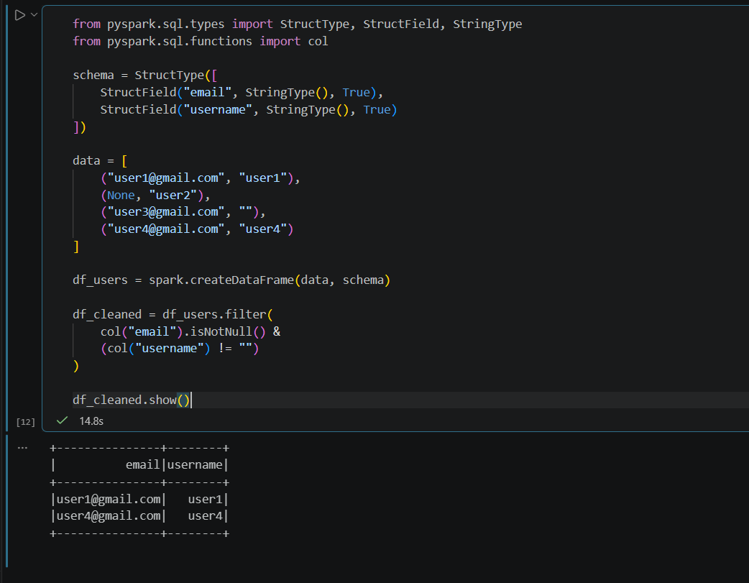
Q13: How do you use the .agg() function to calculate multiple statistics at once, such as the min, max, and mean of the price column?
Ans-The agg() function allows multiple aggregate functions to be applied to a column at the same time.
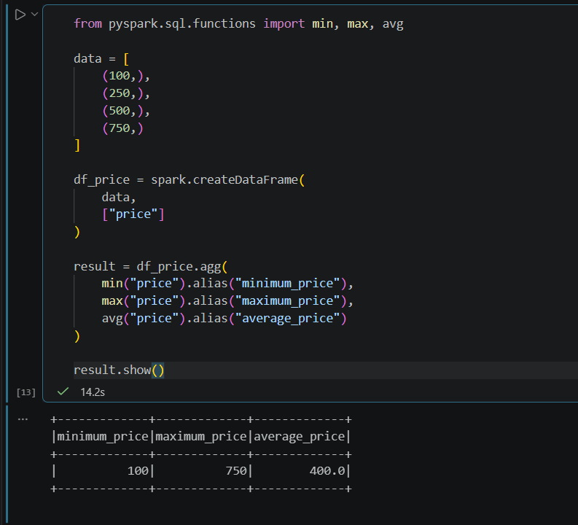

Q14: In the context of cleaning a dataset, what is the risk of using inferSchema=true when your source data contains messy or inconsistent date formats?
Ans- Using inferSchema=True with messy or inconsistent date formats can cause Spark to infer an incorrect data type or fail to correctly parse some date values.

For example, dates may appear in different formats such as:

2026-07-20
20/07/2026
July 20, 2026

Spark may not interpret all these values consistently. This can lead to null values, incorrect data types, failed transformations, and incorrect sorting or filtering.

Therefore, it is safer to explicitly define the schema and specify the date format when working with inconsistent date data.

Q15: Write a final processing pipeline that:
- Filters out duplicates.
- Fills null prices with 0.
- Groups by store_id to calculate total revenue.
Ans-The following pipeline removes duplicate records, fills null prices with 0, and calculates the total revenue for each store.
